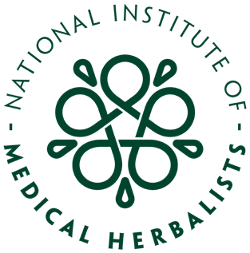

157th Annual General Meeting of the Institute

Held online on Sunday 26th September 2021 at 14:00

EMMA BARKER’S SPEECH

Well, where to start! I just hope to get through this without blubbing! Although that’s highly unlikely. Public speaking is not my forte so apologies everyone if I fluff this up! I shall do my best….

I think the silence that followed the announcement that you would be stepping down as our President at July’s Council meeting, revealed some shock and surprise at your decision. You have done such an amazing job in this role and steered us so well through this period of transition, that I for one had not considered taking the next steps without you.

You are a very generous and kind man and have given me a huge amount of support throughout my time on Council, as I am sure the same can be said for all of our current Council members. I certainly wouldn’t have had the confidence to take on the roles I currently hold without your encouragement, steady advice, and unwavering guidance.

I will be very sad to see you go, but totally respect your decision to do so. I know that you will remain lurking in the background, supporting the Institute in other ways and assisting us to progress plans further - to unfold those plans that you have helped put in place to better the organisation. Preparations that will develop our external reach to connect with those outside of our establishment better and maintain the alliances you have already forged for us. To advance our internal provision, striving to grow our resources and provide continued support to our members at a level expected of a professional association and, of course, ensuring that the Institute continues to thrive and grow. Your continued support with some of these future projects is hugely appreciated. Thank you.

As you have already done in your President’s welcome for today’s AGM, I would also like to take this opportunity to thank your husband Paul, a sometimes-forgotten supporter of our work and one of a long line of Institute widows that have taken care of our former Presidents in the past. I hope that you will now both have the time to have many great adventures together. So happy exploring and safe travels. They are well deserved.

So, to finish off, it almost goes without saying that it has been a pleasure and an honour to have served on Council alongside you. Thank you for all your hard work and as the presidential baton is passed on, I am deeply saddened to end this chapter but also very excited to commence this journey with my Council team mates, our Chief Executive James, and the office team who have worked so hard for us to arrive at this sensational point in time, and I look forward to welcoming and working with our incoming members of the Council team as well.

I know that you don’t see it, but you are an inspiration - and have securely woven a hugely positive thread into the ever-growing tapestry of the Institute’s history, of which you should be immensely proud. Thank you Mr President, and farewell for now, but not goodbye!

